Exercise 2 Date:

Develop and compare CLI, GUI, and Voice User Interfaces (VUI) for the same task and assess user satisfaction using Python (Tkinter for GUI, Speech Recognition for VUI), Terminal

AIM:

The aim is to develop and compare Command Line Interface (CLI), Graphical User Interface (GUI), and Voice User Interface (VUI) for the same task, and assess user satisfaction using Python (with Tkinter for GUI and Speech Recognition for VUI) and Terminal.

PROCEDURE:

- CLI (Command Line Interface)

CLI implementation where users can add, view, and remove tasks using the terminal.

tasks = []

def add_task(task):
tasks.append(task)
print(f"Task '{task}' added successfully.")

def view_tasks():
if tasks:
print("\nYour tasks are:")
for idx, task in enumerate(tasks, 1):
print(f"{idx}. {task}")
print("End of task list.")
else:
print("No tasks to show.")

def remove_task(task_number):
if 0 < task_number <= len(tasks):
removed_task = tasks.pop(task_number - 1)
print(f"Task '{removed_task}' removed successfully.")
else:
print("Invalid task number.")

def main():
while True:
print("\nOptions:")
print("1. Add Task")
print("2. View Tasks")
print("3. Remove Task")
print("4. Exit")

choice = input("Enter your choice: ")

if choice == '1':
task = input("Enter task: ")
add_task(task)
print("Task added...\n")

elif choice == '2':
view_tasks()
print("Operation completed.\n")

elif choice == '3':
task_number = int(input("Enter task number to remove: "))
remove_task(task_number)
print("Task removal process completed.\n")

elif choice == '4':
print("Exiting the program. Thank you!")
break

else:
print("Invalid choice. Please try again.")

if __name__ == "__main__":
main()

Sample Output:

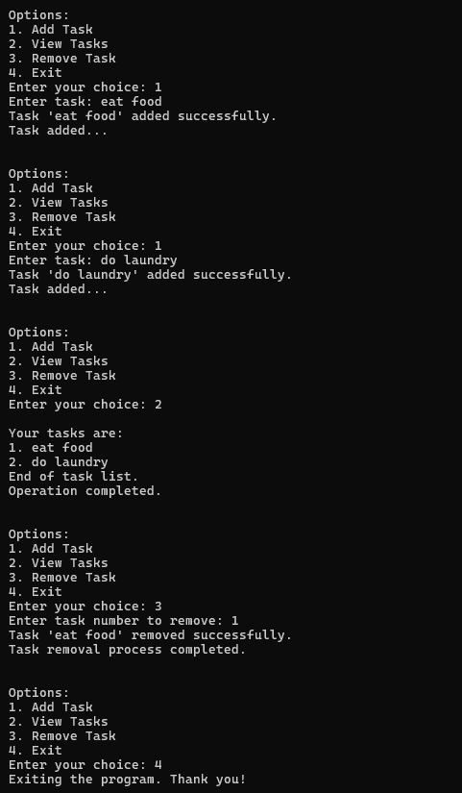

GUI (Graphical User Interface)

Tkinter to create a simple GUI for our To-Do List application.

import tkinter as tk
from tkinter import messagebox

tasks = []

# Add task function
def add_task():
task = task_entry.get()
if task:
tasks.append(task)
task_entry.delete(0, tk.END)
update_task_list()
messagebox.showinfo("Success", f"Task '{task}' added successfully!")
else:
messagebox.showwarning("Warning", "Task cannot be empty")

# Update listbox
def update_task_list():
task_list.delete(0, tk.END)
for task in tasks:
task_list.insert(tk.END, task)

# Remove task function
def remove_task():
selected_task_index = task_list.curselection()
if selected_task_index:
removed_task = tasks.pop(selected_task_index[0])
update_task_list()
messagebox.showinfo("Removed", f"Task '{removed_task}' removed successfully!")
else:
messagebox.showwarning("Warning", "Please select a task to remove")

# GUI window
app = tk.Tk()
app.title("To-Do List")

# Entry field
task_entry = tk.Entry(app, width=40)
task_entry.pack(pady=10)

# Add button
add_button = tk.Button(app, text="Add Task", width=15, command=add_task)
add_button.pack(pady=5)

# Remove button
remove_button = tk.Button(app, text="Remove Task", width=15, command=remove_task)
remove_button.pack(pady=5)

# Listbox to show tasks
task_list = tk.Listbox(app, width=40, height=10)
task_list.pack(pady=10)

# Run the GUI
app.mainloop()

Sample Output:

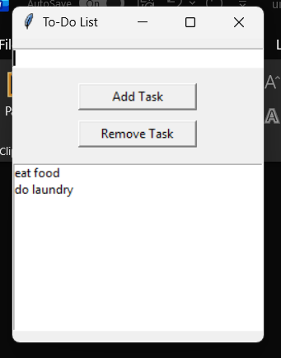
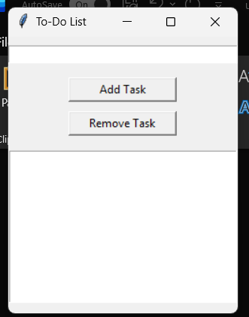

VUI (Voice User Interface)

speech_recognition library for voice input and the pyttsx3 library for text-to-speech output. Make sure you have these libraries installed (pip install SpeechRecognition pyttsx3).

import pyttsx3

tasks = []

engine = pyttsx3.init()

def speak(text):
print(text)
engine.say(text)
engine.runAndWait()

def add_task(task):
tasks.append(task)
speak(f"Task {task} added")

def view_tasks():
if tasks:
speak("Your tasks are")
for i, task in enumerate(tasks, 1):
speak(f"{i}. {task}")
else:
speak("No tasks to show")

def remove_task(task_number):
if 0 < task_number <= len(tasks):
removed_task = tasks.pop(task_number - 1)
speak(f"Task {removed_task} removed")
else:
speak("Invalid task number")

# Simulated voice input
def recognize_speech():
command = input("Type command (simulate voice): ")
return command.lower()

def main():
while True:
speak("Say add task, view tasks, remove task, or exit")

command = recognize_speech()

if not command:
continue

if "add task" in command:
speak("What is the task")
task = recognize_speech()
if task:
add_task(task)

elif "view tasks" in command:
view_tasks()

elif "remove task" in command:
speak("Which task number")
num = recognize_speech()
if num.isdigit():
remove_task(int(num))

elif "exit" in command:
speak("Exiting program")
break

else:
speak("Invalid command")

if __name__ == "__main__":
main()

Sample Output:

